**Assignment 29.1**

**Write a hive UDF that implements functionality of string concat_ws(string SEP, array). This UDF will accept two arguments, one string and one array of string. It will return a single string where all the elements of the array are separated by the SEP.**

**Here is the java code to return all elements of the array separated by separator.**

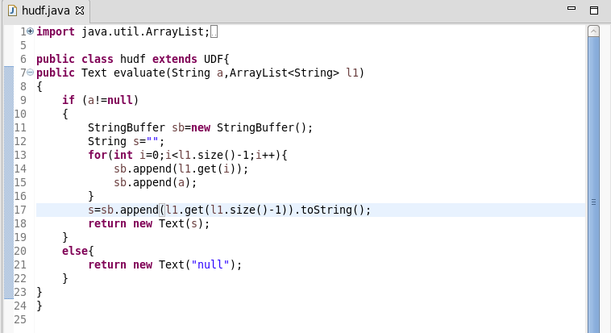

**Here, adding the jar file and creating the table named as ‘hudf’**

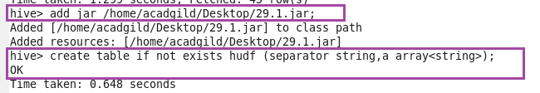

**Creating temporary function ‘concat’ then inserting the data into the created table ‘hudf’ using insert function.**

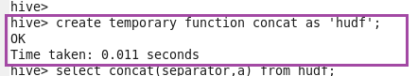

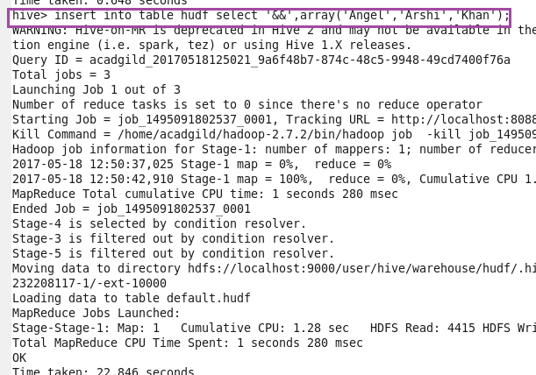

**Describing the table.**

**Performing basic select operation.**

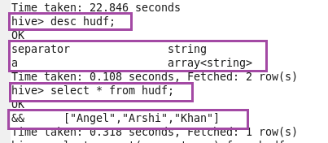

**Retrieving data using temporary function.**

